**MY CERTIFICATES**

**STUDENT NAME:** AGNIV PRAMANICK

**USN:** 1NT21IS017

**BRANCH:** INFORMATION SCIENCE AND ENGINEERING

**SEMESTER:** 4

1. **DIGITAL SKILLS: USER EXPERIENCE**

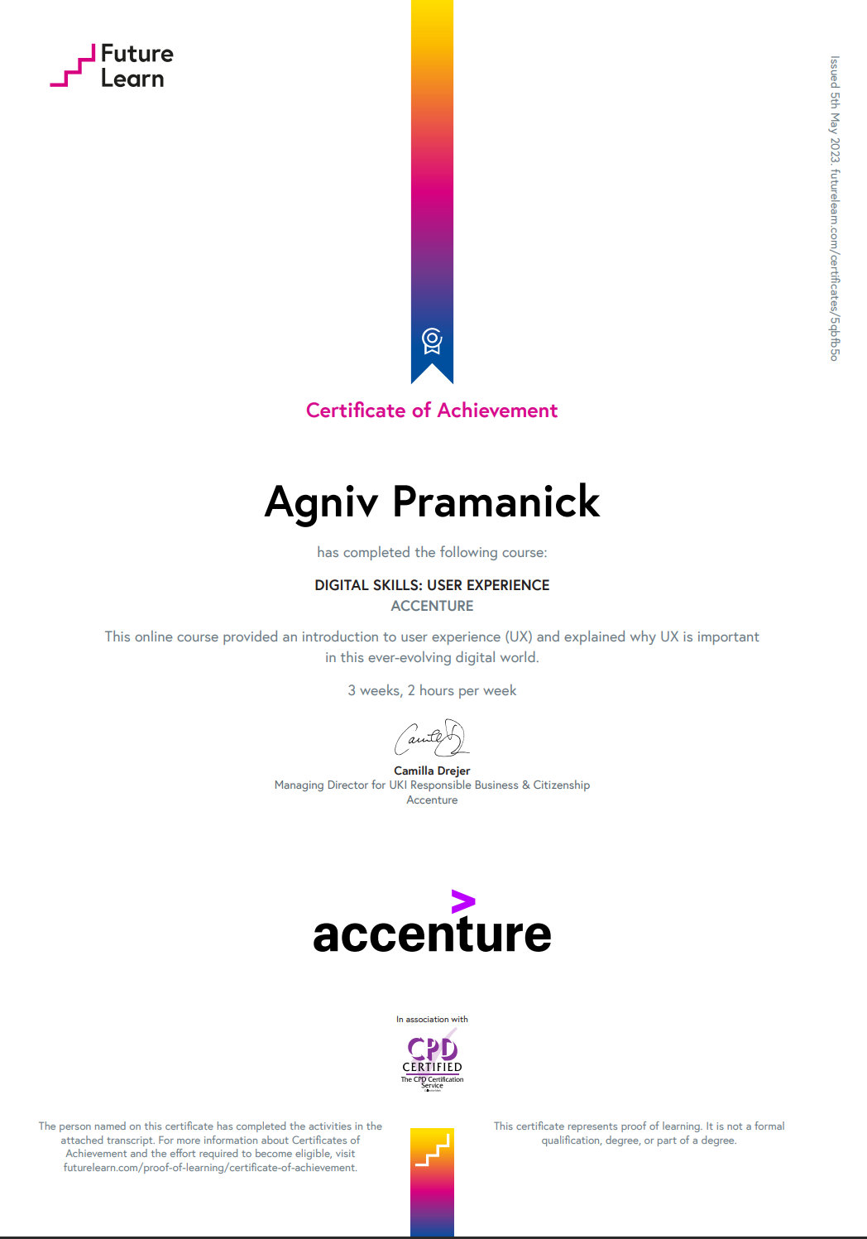

**LINK:**

[Agniv Pramanick 's Certificate of Achievement for Digital Skills: User Experience (futurelearn.com)](https://www.futurelearn.com/certificates/5qbfb5o)

1. **UI / UX FOR BEGINNERS**

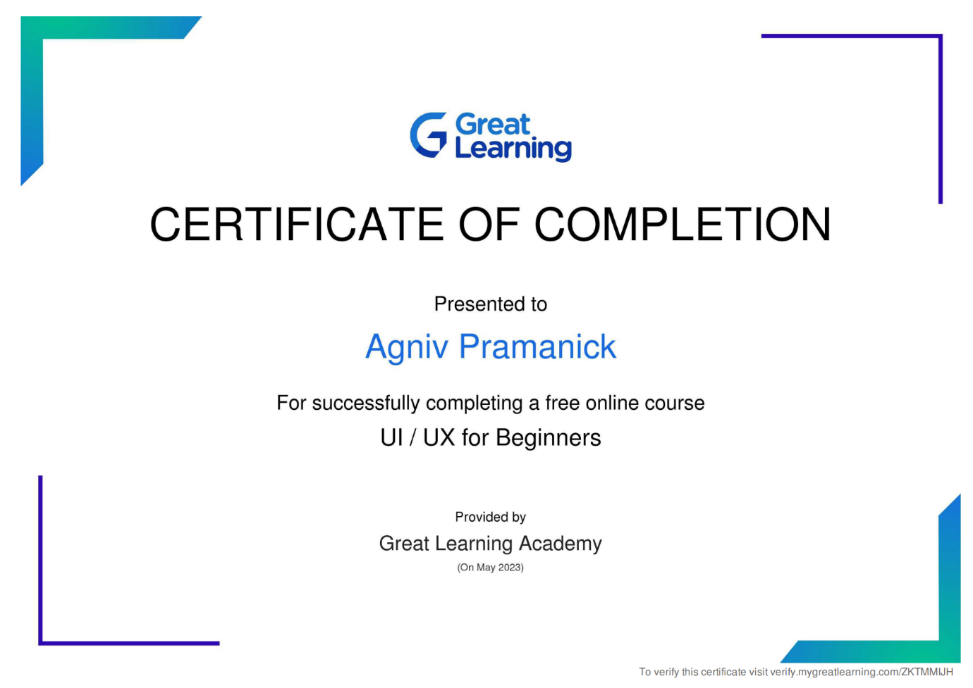

**LINK:**

[Course Certificate (mygreatlearning.com)](https://verify.mygreatlearning.com/verify/ZKTMMIJH)

1. **GET STARTED WITH FIGMA**

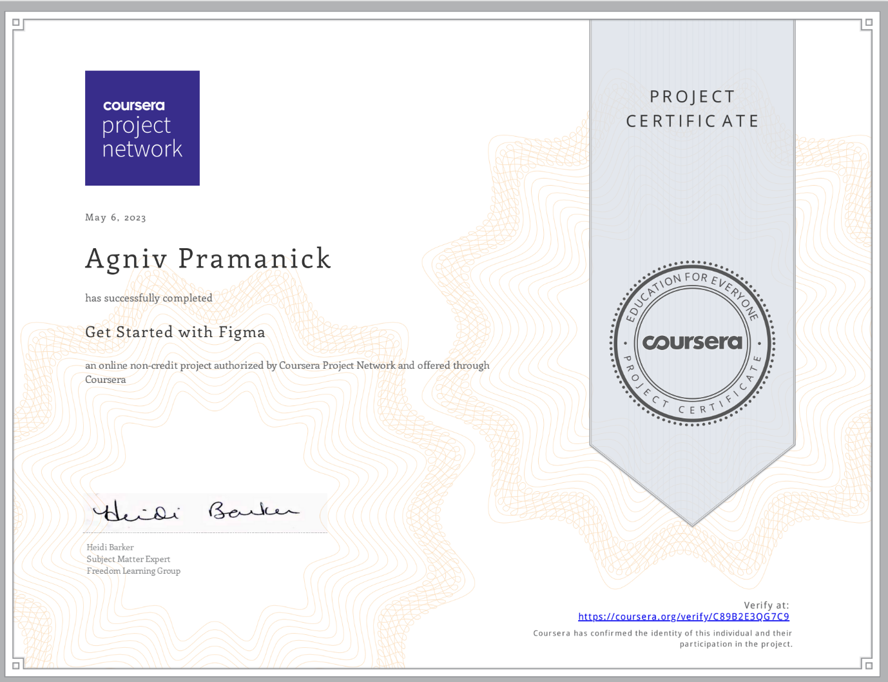

**LINK:**

<https://coursera.org/verify/C89B2E3QG7C9>

1. **USE CANVA TO CREATE SOCIAL MEDIA VISUALS FOR BUSINESS**

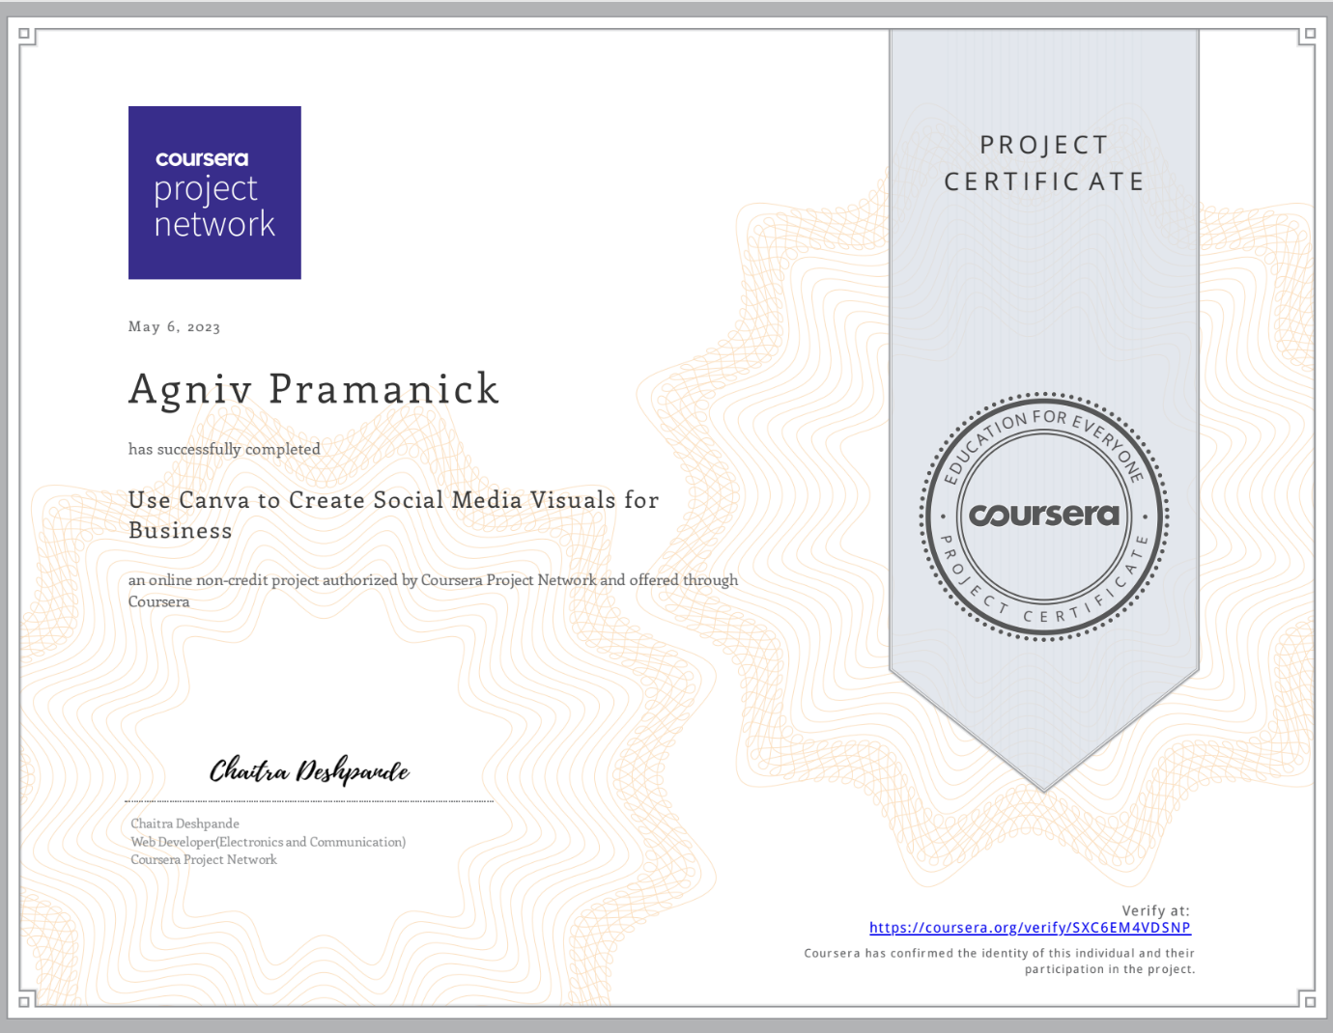

**LINK:**

<https://coursera.org/verify/SXC6EM4VDSNP>

1. **CREATE ANIMATED SOCIAL MEDIA POSTS USING CANVA**

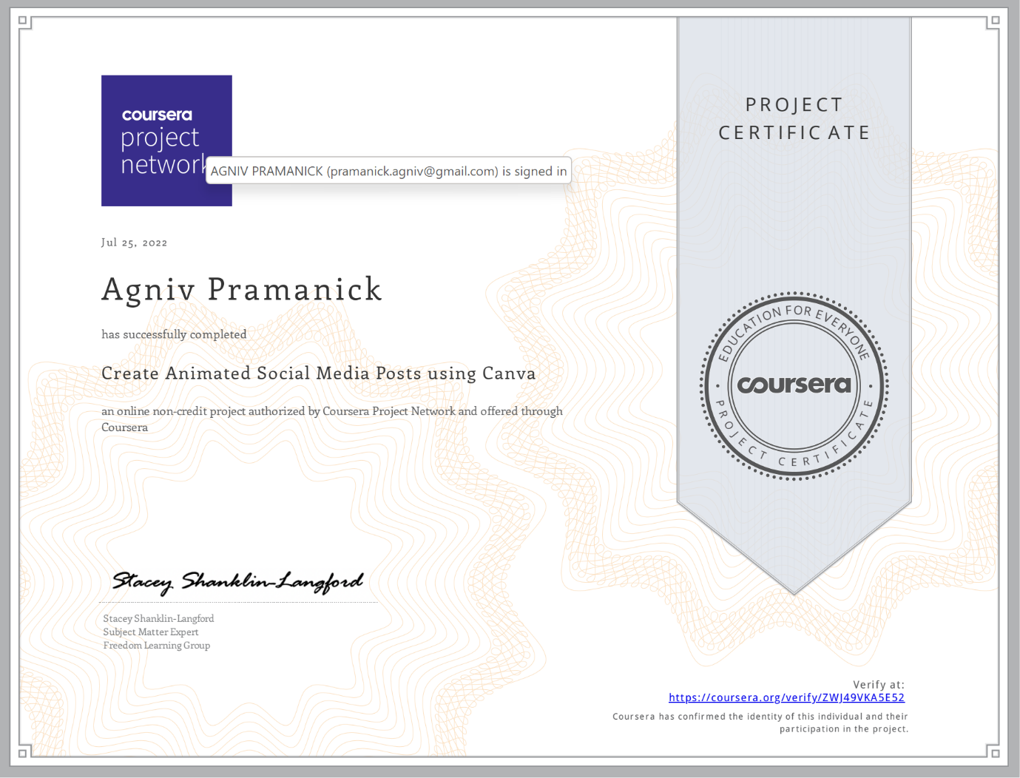

**LINK:**

<https://coursera.org/verify/ZWJ49VKA5E52>